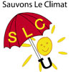
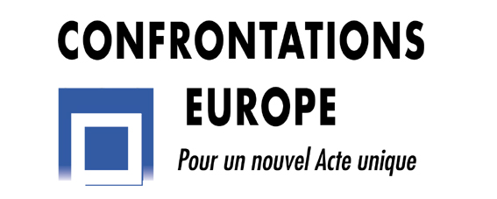
SLC - Sauvons Le Climat
&
Confrontations Europe

European Conference

Tuesday, October 7th 2008
Palais des Académies, Rue Ducale 1, Brussels

“Optimizing the mitigation of carbon dioxide emissions in Europe”
« Réduire (vraiment) les émissions de gaz à effet de serre »

5:00 - 5:10 | Welcome address – Accueil  André Berger, Climatologist, Member of the Belgium Académie Royale and of the French Académie des Sciences
5:10 - 5:30 | Introduction  Jean-Arnold Vinois, Head of the Energy Policy and Security of Supply Unit, DG Energy & Transport, European Commission
5:30 - 6:05 | “Life-cycle analysis of carbon dioxide emissions from different energy sources”  « Analyse du cycle de vie des émissions de gaz à effet de serre selon leur source »  Dr. Stefan Hirschberg, Head of the Laboratory for Energy Systems Analysis in the Paul Scherrer Institut, Switzerland
6:05 - 6:35 | “Cost criterion for the mitigation of carbon dioxide emissions”  « Le critère du coût dans la réduction des émissions de gaz à effet de serre »  Pierre Bacher, Consultant for the French Academy of Technology and the French parliamentary office on the evaluation of scientific and technological options (OPECST)
6:35 - 7:05 | “Discussion of the “3x20” recommendation of the European Commission”  « Discussion sur l’objectif “3x20” de la Commission européenne »  Hervé Nifenecker, President of Save the Climate (SLC – Sauvons Le Climat)
7:05 - 7:40 | Discussion
7:40 - 8:00 | Concluding remarks - Conclusions  Claude Fischer, Secretary General of Confrontations Europe and Director of Les Entretiens européens

The conference will be simultaneously translated into English and French.
La conférence sera traduite simultanément en anglais et en français.

